|  |
| --- |
| BOOKSHOP MANAGEMENT SYSYTEM |
| VEHICLE INSURANCE |
| Project Documentation of DISM (Semester II) |

**our team members**

* TEHREEM SULTANA Student 1107670

* MEHWISH TARIQ student 1114548
* ESHA JAWAID student 1106968
* MOHAMMAD AFFAN KHAN student 1088697

**Faculty** = Miss Aatika Liaquat

**Batch Code** = 1804B1

**Curriculum**= 6673

**Semester**= HDSE I

**FORNTEND**

FORNTEND:-

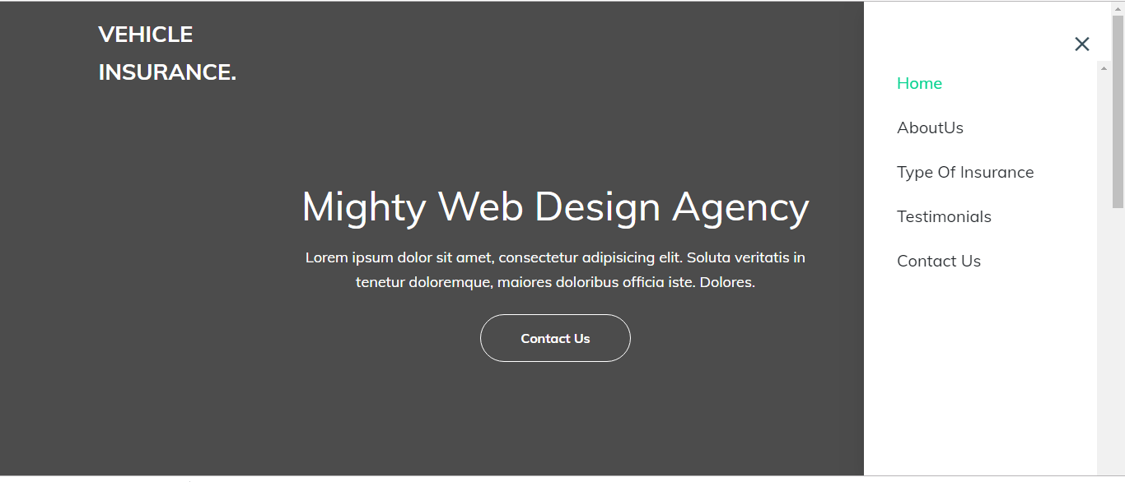

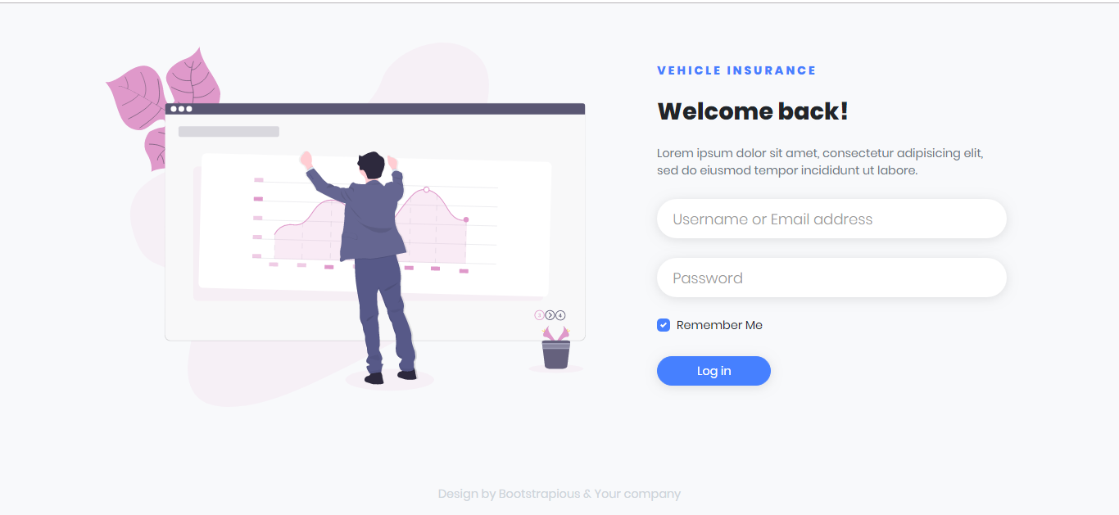

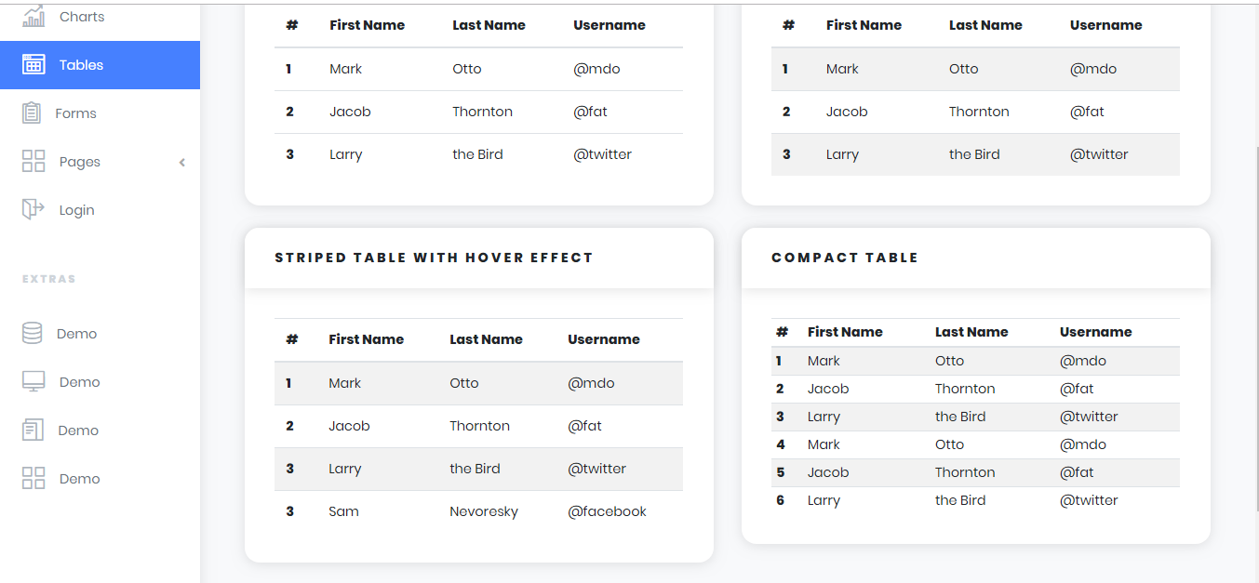

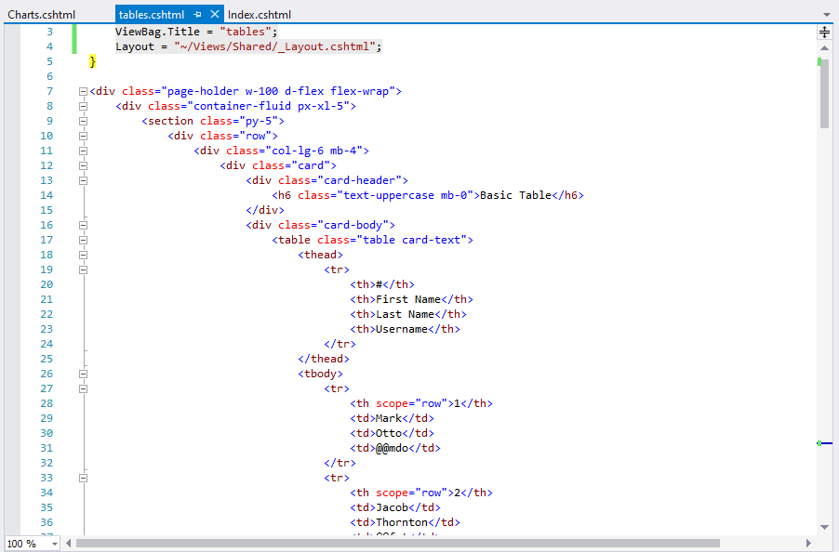

BACKEND:-

